ΕΝΟΤΗΤΑ 6 : ΕΠΑΝΑΛΗΨΗ

* **Λύνω προσεκτικά τις πιο κάτω μαθηματικές προτάσεις:**

7 Χ 2 =…… 40 ÷ 5 =…… 1 Χ 9 =…… 14 ÷ 7 =……

10 Χ 10 =…… 20 ÷ 2 =…… 8 Χ 2 =…… 16 ÷ 2 =……

6 Χ 5 =…… 20 + 7 =…… 7 + 7 =…… 20 - 6 =……

9 + 9 =…… 16 - 8 =…… 6 + 10 =…… 7 + 6 =……

20 Χ 3 =…… 20 ÷ 5 =…… 8 Χ 10 =…… 60 ÷ 2 =……

30 Χ 0 =…… 90 ÷ 1 =…… 60 Χ 1 =…… 3 Χ 10 =……

30 + 70 =…… 50 - 10 =…… 60 + 7 =…… 88 - 8 =……

0 + 50 =…… 90 + 0 =…… 30 - 0 =…… 60 - 30 =……

* **Βρίσκω τον αριθμό που λείπει:**

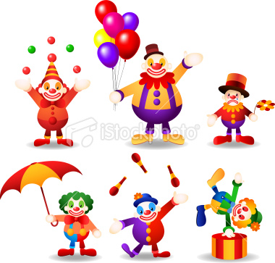8 Χ ………=80 70 ÷ ………= 70

[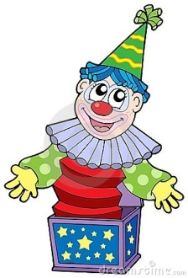](http://www.google.co.uk/url?sa=i&rct=j&q=clown+cartoon&source=images&cd=&cad=rja&docid=L7u2AhtV7l9tsM&tbnid=6YKqZLKqg6Vz6M:&ved=0CAUQjRw&url=http://www.dreamstime.com/royalty-free-stock-images-cartoon-clown-box-image8254059&ei=PN48Uen6F4jWPMDKgGA&bvm=bv.43287494,d.ZWU&psig=AFQjCNF590AEjIy02iHZMU_RVJ589_6kUQ&ust=1363029928642463)……… + 20=50 ……… ÷ 2 = 7

4 + ………= 14 99 - ………= 9

……… Χ 80=0 ……… - 10 = 8

2 Χ ………=80 16 ÷ ………= 8

Ονοματεπώνυμο:........................................................... Τάξη:..........

* 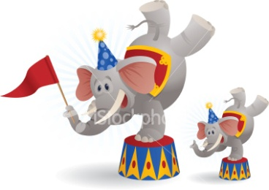**Σκέφτομαι και βάζω (+), (-), (Χ) ή (÷) για να είναι σωστές οι μαθηματικές προτάσεις:**

4 …… 70= 74 8 …… 8 = 16

30 …… 10= 20 83 …… 3 = 80

9 …… 10= 90 70 …… 1 = 70

2 …… 6= 12 70 …… 30 = 100

* 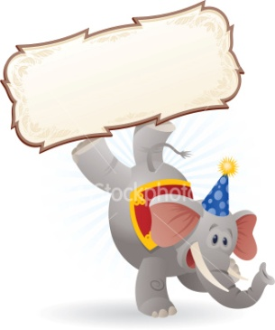**Γράφω κάτω από τον κάθε αριθμό αν είναι ΑΡΤΙΟΣ ή ΠΕΡΙΤΤΟΣ:**

25

50



36

93



78

49

87

14



100

9

11

62

* **[](http://www.google.co.uk/url?sa=i&rct=j&q=clooun+cartoon&source=images&cd=&cad=rja&docid=AlH44uCr9XzuZM&tbnid=I2DhjLZ_qTncqM:&ved=0CAUQjRw&url=http://yaymicro.com/vector/clown-cartoon/4097108&ei=qqs8UcmTLYmOOO6cgfAM&bvm=bv.43287494,d.ZWU&psig=AFQjCNE180cUfZV9SxG3K--fLVeVWKqKgw&ust=1363016918444658)Επιλέγω τα σχέδια που έχουν άξονα συμμετρίας και να τον δείχνω:**

**[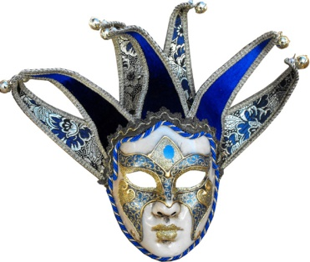](http://www.google.co.uk/url?sa=i&rct=j&q=carnival+mask+cartoon&source=images&cd=&cad=rja&docid=5sq5UCASnDHiuM&tbnid=4fMsvGE5_7pSzM:&ved=0CAUQjRw&url=http://www.escapade.co.uk/masks-sale/venetian-masks/jolly-disegno-venetian-mask.asp&ei=6qo8UdnbGoKrPM3agNgL&bvm=bv.43287494,d.ZWU&psig=AFQjCNGMmxSmNN4CNQSHtnhRxw9hlUeo-g&ust=1363016591608003)[](http://www.google.co.uk/url?sa=i&rct=j&q=clooun+cartoon&source=images&cd=&cad=rja&docid=Va6tf0ziqv8fzM&tbnid=fvEkeVZqY_luGM:&ved=0CAUQjRw&url=http://www.123rf.com/photo_17320437_large-isolated-cartoon-clown-face.html&ei=dKs8UeOSBIfZPLu_gIAD&bvm=bv.43287494,d.ZWU&psig=AFQjCNE180cUfZV9SxG3K--fLVeVWKqKgw&ust=1363016918444658)[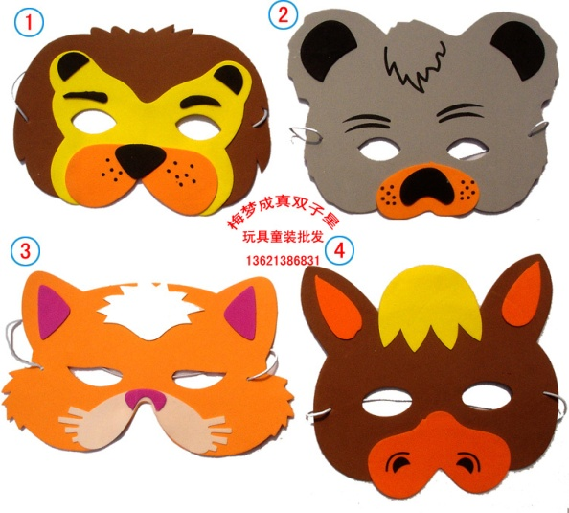](http://www.google.co.uk/url?sa=i&rct=j&q=carnival+mask+cartoon&source=images&cd=&cad=rja&docid=ZlrGu5NB88LBYM&tbnid=QpFf5fYcR2etDM:&ved=0CAUQjRw&url=http://www.aliexpress.com/compare/compare-masks-carnival.html&ei=Sqo8Uc_7JYjTPLLNgIgK&bvm=bv.43287494,d.ZWU&psig=AFQjCNGMmxSmNN4CNQSHtnhRxw9hlUeo-g&ust=1363016591608003)**

**[](http://www.google.co.uk/url?sa=i&rct=j&q=clown+cartoon&source=images&cd=&cad=rja&docid=n6a41Al2w_rs_M&tbnid=Y8W0Cvvc2ML10M:&ved=0CAUQjRw&url=http://graphicleftovers.com/graphic/cartoon-circus-ringmasterwith-top-hat/&ei=Ft88UdGgG4SrOqHTgPgJ&bvm=bv.43287494,d.ZWU&psig=AFQjCNH08wAM4ReUDavWDzcBP64cPfW3RA&ust=1363030006615522)[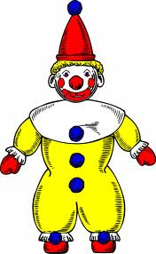](http://www.google.co.uk/url?sa=i&rct=j&q=clown+cartoon&source=images&cd=&cad=rja&docid=n6a41Al2w_rs_M&tbnid=Y8W0Cvvc2ML10M:&ved=0CAUQjRw&url=http://www.freestockphotos.biz/stockphoto/17180&ei=Dt88Uc-7K8SxPPD7geAJ&bvm=bv.43287494,d.ZWU&psig=AFQjCNH08wAM4ReUDavWDzcBP64cPfW3RA&ust=1363030006615522)[](http://www.google.co.uk/imgres?q=clown+cartoon&hl=en&sa=X&qscrl=1&rlz=1T4TEUA_en___CY501&biw=886&bih=416&tbm=isch&tbnid=ellSpMXLKsXG8M:&imgrefurl=http://www.toonvectors.com/clip-art/cartoon-clown-juggling/3247&docid=xnbRBayJlj0sxM&imgurl=http://cdn.toonvectors.com/images/2/3247/toonvectors-3247-940.jpg&w=940&h=940&ei=dt48UdOAF8WrPOiGgJAD&zoom=1&ved=1t:3588,r:33,s:0,i:228&iact=rc&dur=3393&page=3&tbnh=176&tbnw=176&start=20&ndsp=15&tx=98&ty=95)[](http://www.google.co.uk/url?sa=i&rct=j&q=clown+cartoon+face&source=images&cd=&cad=rja&docid=dFSb1RsCZpGTEM&tbnid=d5z0JYzWD5kB9M:&ved=0CAUQjRw&url=http://www.butterscotchtheclown.ca/testimonials.html&ei=h948UcvuMoPUPKW9gYgJ&bvm=bv.43287494,d.ZWU&psig=AFQjCNE_63KQnzOskfpgoCo4PhyPMvFCwA&ust=1363030012975084)**

* **Παρατηρώ προσεκτικά την πιο κάτω γραφική παράσταση και απαντώ τις πιο κάτω ερωτήσεις:**

|  |  |  |  |  |  |  |  |  |  |
| --- | --- | --- | --- | --- | --- | --- | --- | --- | --- |
| σοκολατίνα | [http://www.search-best-cartoon.com/cartoon-clowns/cartoon-clown-head-1.jpg](http://www.google.co.uk/url?sa=i&rct=j&q=clown+cartoon&source=images&cd=&cad=rja&docid=dbvfZuI7fo43aM&tbnid=ESp45ea7wfJPhM:&ved=0CAUQjRw&url=http://cartoon-icio.ru/search.php?id=18659&ei=-OM8UdjhBoq_PJOggJgG&bvm=bv.43287494,d.ZWU&psig=AFQjCNG_SuXfPDLF9UbgFax1YiZ3ShXp5w&ust=1363031139103748) | [http://www.search-best-cartoon.com/cartoon-clowns/cartoon-clown-head-1.jpg](http://www.google.co.uk/url?sa=i&rct=j&q=clown+cartoon&source=images&cd=&cad=rja&docid=dbvfZuI7fo43aM&tbnid=ESp45ea7wfJPhM:&ved=0CAUQjRw&url=http://cartoon-icio.ru/search.php?id=18659&ei=-OM8UdjhBoq_PJOggJgG&bvm=bv.43287494,d.ZWU&psig=AFQjCNG_SuXfPDLF9UbgFax1YiZ3ShXp5w&ust=1363031139103748) |  |  |  |  |  |  |  |
| κρέμα | [http://www.search-best-cartoon.com/cartoon-clowns/cartoon-clown-head-1.jpg](http://www.google.co.uk/url?sa=i&rct=j&q=clown+cartoon&source=images&cd=&cad=rja&docid=dbvfZuI7fo43aM&tbnid=ESp45ea7wfJPhM:&ved=0CAUQjRw&url=http://cartoon-icio.ru/search.php?id=18659&ei=-OM8UdjhBoq_PJOggJgG&bvm=bv.43287494,d.ZWU&psig=AFQjCNG_SuXfPDLF9UbgFax1YiZ3ShXp5w&ust=1363031139103748) | [http://www.search-best-cartoon.com/cartoon-clowns/cartoon-clown-head-1.jpg](http://www.google.co.uk/url?sa=i&rct=j&q=clown+cartoon&source=images&cd=&cad=rja&docid=dbvfZuI7fo43aM&tbnid=ESp45ea7wfJPhM:&ved=0CAUQjRw&url=http://cartoon-icio.ru/search.php?id=18659&ei=-OM8UdjhBoq_PJOggJgG&bvm=bv.43287494,d.ZWU&psig=AFQjCNG_SuXfPDLF9UbgFax1YiZ3ShXp5w&ust=1363031139103748) |  | [http://www.search-best-cartoon.com/cartoon-clowns/cartoon-clown-head-1.jpghttp://www.search-best-cartoon.com/cartoon-clowns/cartoon-clown-head-1.jpghttp://www.search-best-cartoon.com/cartoon-clowns/cartoon-clown-head-1.jpghttp://www.search-best-cartoon.com/cartoon-clowns/cartoon-clown-head-1.jpghttp://www.search-best-cartoon.com/cartoon-clowns/cartoon-clown-head-1.jpg](http://www.google.co.uk/url?sa=i&rct=j&q=clown+cartoon&source=images&cd=&cad=rja&docid=dbvfZuI7fo43aM&tbnid=ESp45ea7wfJPhM:&ved=0CAUQjRw&url=http://cartoon-icio.ru/search.php?id=18659&ei=-OM8UdjhBoq_PJOggJgG&bvm=bv.43287494,d.ZWU&psig=AFQjCNG_SuXfPDLF9UbgFax1YiZ3ShXp5w&ust=1363031139103748) | [http://www.search-best-cartoon.com/cartoon-clowns/cartoon-clown-head-1.jpg](http://www.google.co.uk/url?sa=i&rct=j&q=clown+cartoon&source=images&cd=&cad=rja&docid=dbvfZuI7fo43aM&tbnid=ESp45ea7wfJPhM:&ved=0CAUQjRw&url=http://cartoon-icio.ru/search.php?id=18659&ei=-OM8UdjhBoq_PJOggJgG&bvm=bv.43287494,d.ZWU&psig=AFQjCNG_SuXfPDLF9UbgFax1YiZ3ShXp5w&ust=1363031139103748) |  |  |  |  |
| φρουτοσαλάτα | [http://www.search-best-cartoon.com/cartoon-clowns/cartoon-clown-head-1.jpg](http://www.google.co.uk/url?sa=i&rct=j&q=clown+cartoon&source=images&cd=&cad=rja&docid=dbvfZuI7fo43aM&tbnid=ESp45ea7wfJPhM:&ved=0CAUQjRw&url=http://cartoon-icio.ru/search.php?id=18659&ei=-OM8UdjhBoq_PJOggJgG&bvm=bv.43287494,d.ZWU&psig=AFQjCNG_SuXfPDLF9UbgFax1YiZ3ShXp5w&ust=1363031139103748) |  |  |  |  |  |  | [http://www.search-best-cartoon.com/cartoon-clowns/cartoon-clown-head-1.jpg](http://www.google.co.uk/url?sa=i&rct=j&q=clown+cartoon&source=images&cd=&cad=rja&docid=dbvfZuI7fo43aM&tbnid=ESp45ea7wfJPhM:&ved=0CAUQjRw&url=http://cartoon-icio.ru/search.php?id=18659&ei=-OM8UdjhBoq_PJOggJgG&bvm=bv.43287494,d.ZWU&psig=AFQjCNG_SuXfPDLF9UbgFax1YiZ3ShXp5w&ust=1363031139103748) |  |
| τρούφα | [http://www.search-best-cartoon.com/cartoon-clowns/cartoon-clown-head-1.jpg](http://www.google.co.uk/url?sa=i&rct=j&q=clown+cartoon&source=images&cd=&cad=rja&docid=dbvfZuI7fo43aM&tbnid=ESp45ea7wfJPhM:&ved=0CAUQjRw&url=http://cartoon-icio.ru/search.php?id=18659&ei=-OM8UdjhBoq_PJOggJgG&bvm=bv.43287494,d.ZWU&psig=AFQjCNG_SuXfPDLF9UbgFax1YiZ3ShXp5w&ust=1363031139103748) | [http://www.search-best-cartoon.com/cartoon-clowns/cartoon-clown-head-1.jpg](http://www.google.co.uk/url?sa=i&rct=j&q=clown+cartoon&source=images&cd=&cad=rja&docid=dbvfZuI7fo43aM&tbnid=ESp45ea7wfJPhM:&ved=0CAUQjRw&url=http://cartoon-icio.ru/search.php?id=18659&ei=-OM8UdjhBoq_PJOggJgG&bvm=bv.43287494,d.ZWU&psig=AFQjCNG_SuXfPDLF9UbgFax1YiZ3ShXp5w&ust=1363031139103748) |  | [http://www.search-best-cartoon.com/cartoon-clowns/cartoon-clown-head-1.jpg](http://www.google.co.uk/url?sa=i&rct=j&q=clown+cartoon&source=images&cd=&cad=rja&docid=dbvfZuI7fo43aM&tbnid=ESp45ea7wfJPhM:&ved=0CAUQjRw&url=http://cartoon-icio.ru/search.php?id=18659&ei=-OM8UdjhBoq_PJOggJgG&bvm=bv.43287494,d.ZWU&psig=AFQjCNG_SuXfPDLF9UbgFax1YiZ3ShXp5w&ust=1363031139103748) | [http://www.search-best-cartoon.com/cartoon-clowns/cartoon-clown-head-1.jpg](http://www.google.co.uk/url?sa=i&rct=j&q=clown+cartoon&source=images&cd=&cad=rja&docid=dbvfZuI7fo43aM&tbnid=ESp45ea7wfJPhM:&ved=0CAUQjRw&url=http://cartoon-icio.ru/search.php?id=18659&ei=-OM8UdjhBoq_PJOggJgG&bvm=bv.43287494,d.ZWU&psig=AFQjCNG_SuXfPDLF9UbgFax1YiZ3ShXp5w&ust=1363031139103748) |  | [http://www.search-best-cartoon.com/cartoon-clowns/cartoon-clown-head-1.jpg](http://www.google.co.uk/url?sa=i&rct=j&q=clown+cartoon&source=images&cd=&cad=rja&docid=dbvfZuI7fo43aM&tbnid=ESp45ea7wfJPhM:&ved=0CAUQjRw&url=http://cartoon-icio.ru/search.php?id=18659&ei=-OM8UdjhBoq_PJOggJgG&bvm=bv.43287494,d.ZWU&psig=AFQjCNG_SuXfPDLF9UbgFax1YiZ3ShXp5w&ust=1363031139103748) |  |  |

[](http://www.google.co.uk/url?sa=i&rct=j&q=clown+cartoon&source=images&cd=&cad=rja&docid=dbvfZuI7fo43aM&tbnid=ESp45ea7wfJPhM:&ved=0CAUQjRw&url=http://cartoon-icio.ru/search.php?id=18659&ei=-OM8UdjhBoq_PJOggJgG&bvm=bv.43287494,d.ZWU&psig=AFQjCNG_SuXfPDLF9UbgFax1YiZ3ShXp5w&ust=1363031139103748)

Κάθε αντιστοιχεί με 10 παιδιά

Α)Πόσα παιδιά προτιμούν τη σοκολατίνα;…………………………………………………………………

Β) Πόσα παιδιά προτιμούν την κρέμα;…………………………………………………………………………

Γ) Πόσα παιδιά προτιμούν τη φρουτοσαλάτα;……………………………………………………………

Δ) Πόσα παιδιά προτιμούν την τρούφα;………………………………………………………………………

Ε) Πόσα περισσότερα παιδιά προτιμούν τη φρουτοσαλάτα από την κρέμα;………………

Ζ)Πόσα λιγότερα παιδιά προτιμούν τα τη σοκολατίνα από την τρούφα;……………………

1. [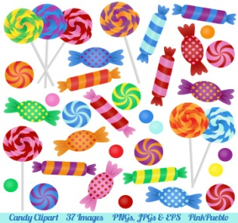](http://www.google.co.uk/url?sa=i&rct=j&q=sweets+clipart&source=images&cd=&cad=rja&docid=4Dy3K8ZOm4QL3M&tbnid=ES7IheRPV9NrNM:&ved=0CAUQjRw&url=http://www.printcandee.com/candy-clipart/&ei=5Oc8UcPWJYrdPaqagJAI&bvm=bv.43287494,d.ZWU&psig=AFQjCNFzcQQyiHKRzHoWQXEEsYqgEYZ1TQ&ust=1363032398885941)Η Ιουλιανή έχει 15 καραμέλες. Θέλει να τις μοιράσει σε 5 φίλες της. Πόσες καραμέλες θα πάρει το κάθε κορίτσι;

Μαθηματική Πρόταση: ……………………………………………………

Απάντηση: ……………………………………………………………………………………………………

1. [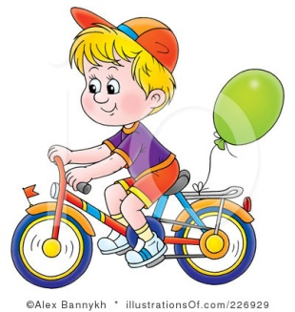](http://www.google.co.uk/url?sa=i&rct=j&q=bicycle+clipart&source=images&cd=&cad=rja&docid=NqH-0HkAWUvpOM&tbnid=B-FTIVPRmMye3M:&ved=0CAUQjRw&url=http://www.illustrationsof.com/226929-royalty-free-bicycle-clipart-illustration&ei=OOg8Ua7zEsbSPLnhgPgI&bvm=bv.43287494,d.ZWU&psig=AFQjCNEvWByGYCmRrO2IANm-_5hQN3fG0A&ust=1363032483803814)Ο Παναγιώτης είχε 85 ευρώ. Χρησιμοποίησε τα 80 ευρώ για να αγοράσει ένα ποδήλατο. Πόσα ευρώ έχει τώρα ο Παναγιώτης;

Μαθηματική Πρόταση: ……………………………………………………

Απάντηση: ……………………………………………………………………………………………………

1. [](http://www.google.co.uk/url?sa=i&rct=j&q=pencils+clipart&source=images&cd=&cad=rja&docid=m8TR3AC8GvxRWM&tbnid=vXJMdvsU3UPWUM:&ved=0CAUQjRw&url=http://www.clipartsfree.net/clipart/7350-happy-pencil-clipart.html&ei=nOg8Ud26OMTOObHqgfgG&bvm=bv.43287494,d.ZWU&psig=AFQjCNFGenH8JW4hIevhM0bAZrGUDnNunA&ust=1363032561889289)Η Στέιση αγόρασε δύο μολύβια. Το ένα μολύβι στοίχιζε 40 σεντ και το άλλο 60 σεντ. Πόσα στοίχιζαν και τα δύο μολύβια συνολικά;

Μαθηματική Πρόταση: ……………………………………………………

Απάντηση: ……………………………………………………………………………………………………

1. [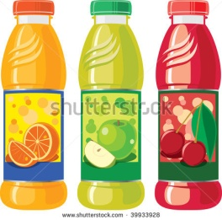](http://www.google.co.uk/url?sa=i&rct=j&q=three+juice+clipart&source=images&cd=&cad=rja&docid=MjLnFHH4wBRlyM&tbnid=DGsGUx3LcmNkkM:&ved=0CAUQjRw&url=http://www.shutterstock.com/pic-39933928/stock-vector-an-illustration-of-three-juice-bottles.html&ei=e-k8UfatI83JPfG0gYgN&bvm=bv.43287494,d.ZWU&psig=AFQjCNFNswliXYQhAde0Vq4nop4QD74hGg&ust=1363032811663968)Ο Γιάννης αγόρασε 3 χυμούς. Ο κάθε χυμός στοίχιζε 30 σεντ. Πόσα στοίχιζαν και οι 3 χυμοί συνολικά;

Μαθηματική Πρόταση: ……………………………………………………

Απάντηση: ……………………………………………………………………………………………………